Introduction
This test program intends to demonstrate the seal performance under site conditions after several reports of failure and inconsistency of leakage.
The subject of this testing is mechanical seal order 950969 modified. This version of mechanical seal was designed based on new seal faces geometry to include lasered wavy face technology.

Test N°3 – (Sep 12 – Sep 18, 2023)
This test will be performed with same faces from test 01 without lapping or re-conditioning.
Barrier fluid will be simulated as per site conditions MonoEthylene Glycol + Water (30%/70%).
The pressure during this test will be increase to 113barg simulating original site conditions.

Seal Configuration
Seal faces
 | Part Drawing | Material | Face condition
Sleeve (1) | C0619166NL | Alloy C-276 | From Test 01
Inner Seal Stator (14) | C0618722SL | Silicon Carbide (SL) | From Test 01
Inner Seal Rotor (15) | C0619339SL | Silicon Carbide (SL) | From Test 01
Outer Seal Stator (14.1) | C0618722SL | Silicon Carbide (SL) | From Test 01
Outer Seal Rotor (15.1) | C0618723SL | Silicon Carbide (SL) | From Test 01

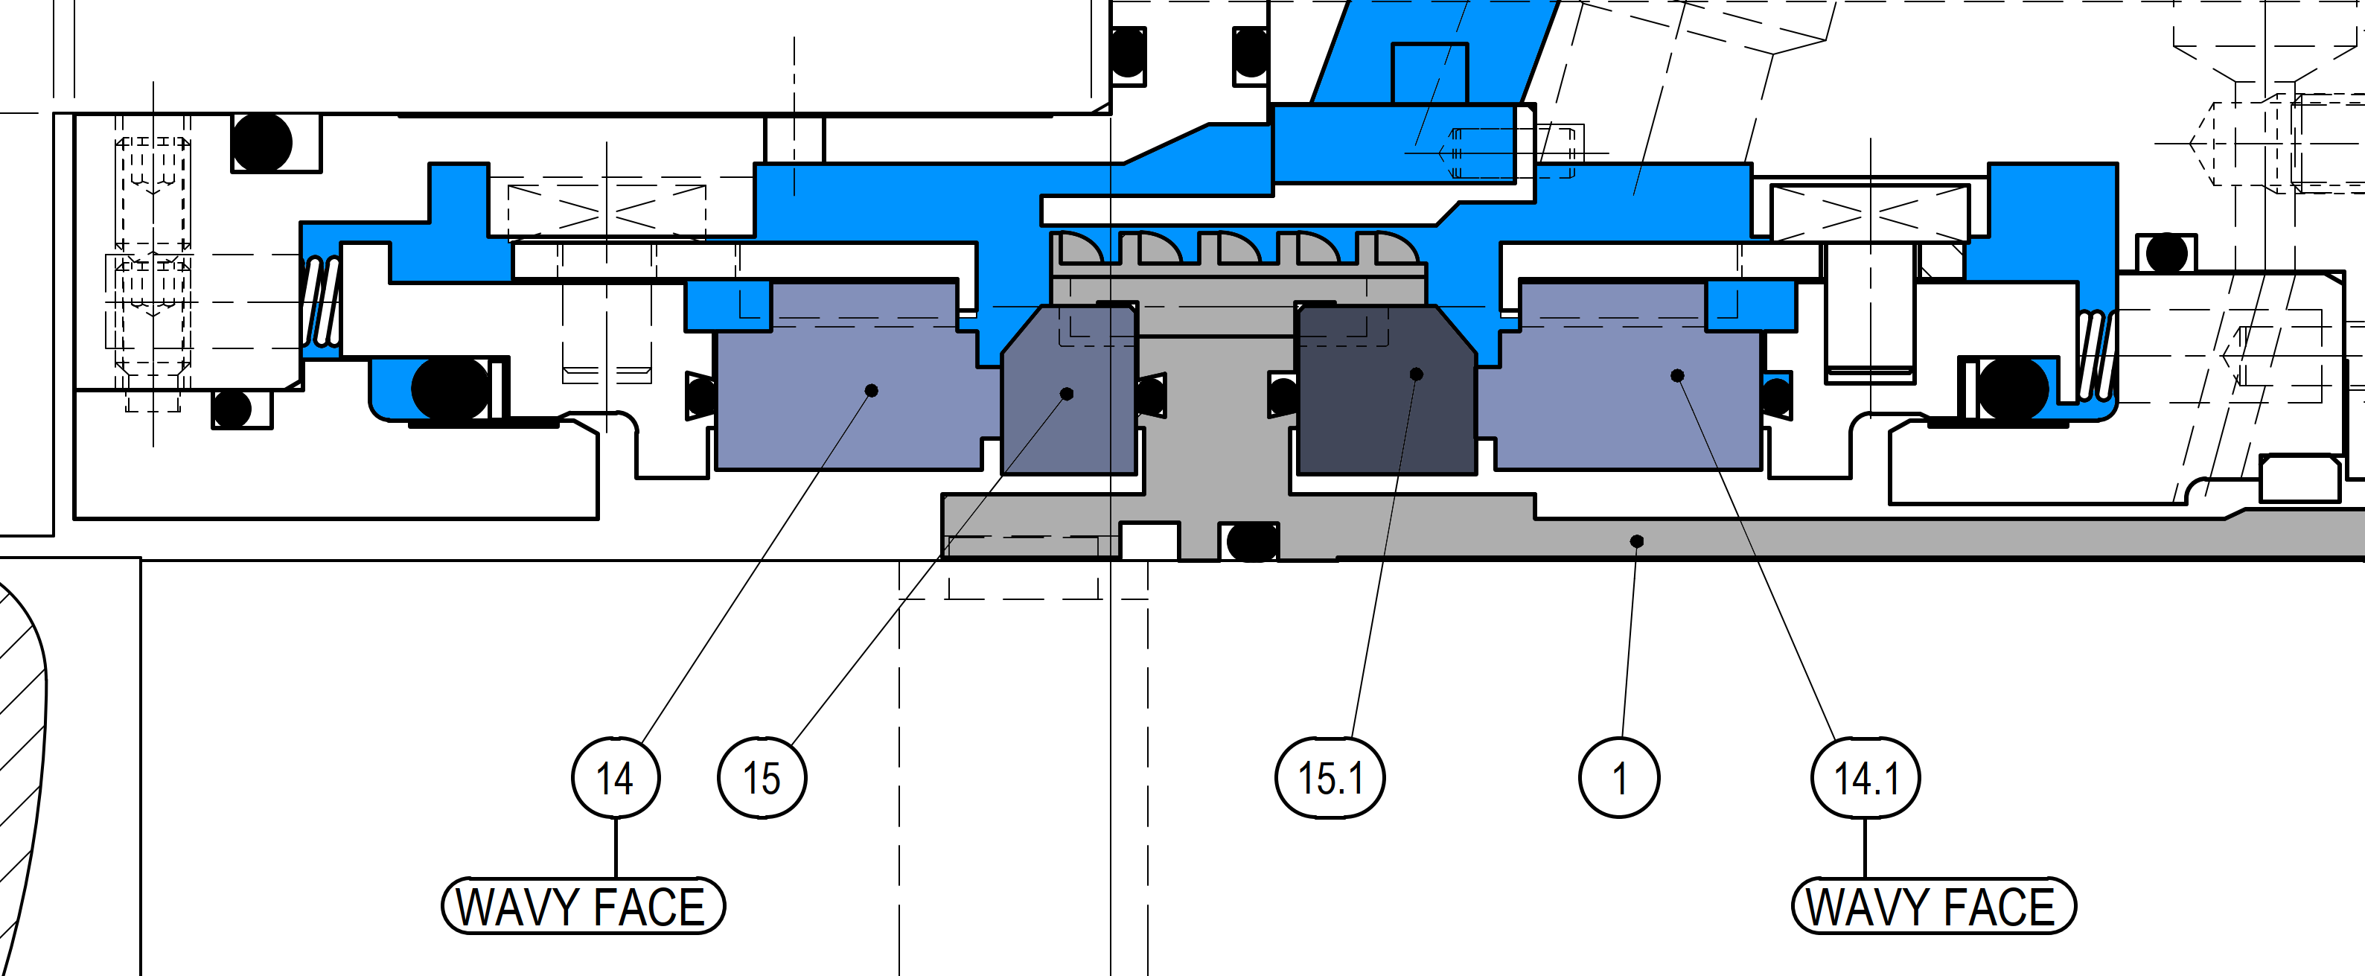
Cross Section of The New Parts

Test Conditions & Results
 | Job seal barrier
Duration | Minimum 144
Speed | 2950 rpm
Fluid | Glycol 30/ Water 70
Pressure | 113 barg
Inlet temp. | 47 °C
Outlet temp. | 54 °C
Inner Seal Leakage | Avg. 28.2 ml/h
Outer Seal Leakage | Avg. 29.7 ml/h
Flow | 13.2-12.2 l/min

Tester Drawing D0571813
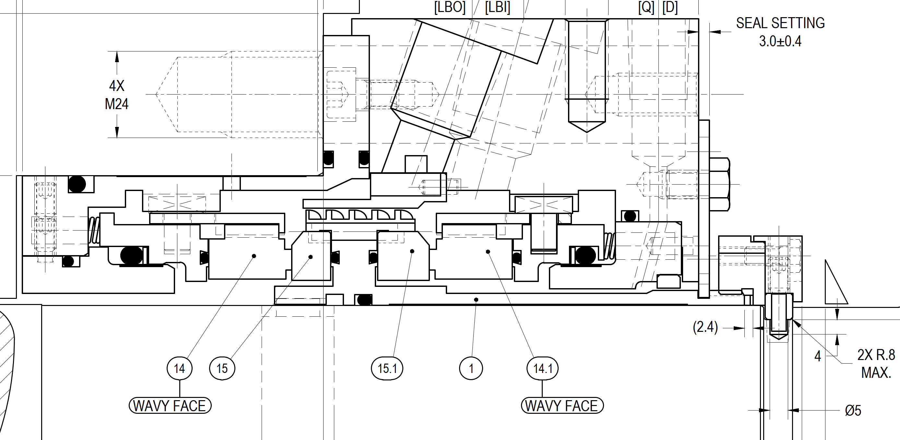

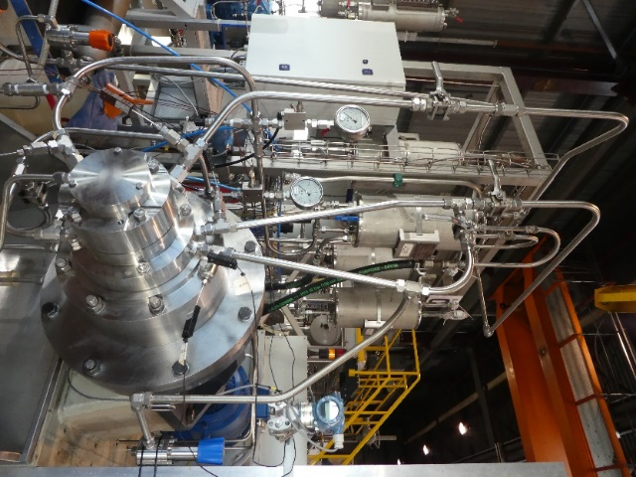
Tester unit B
Logged Data
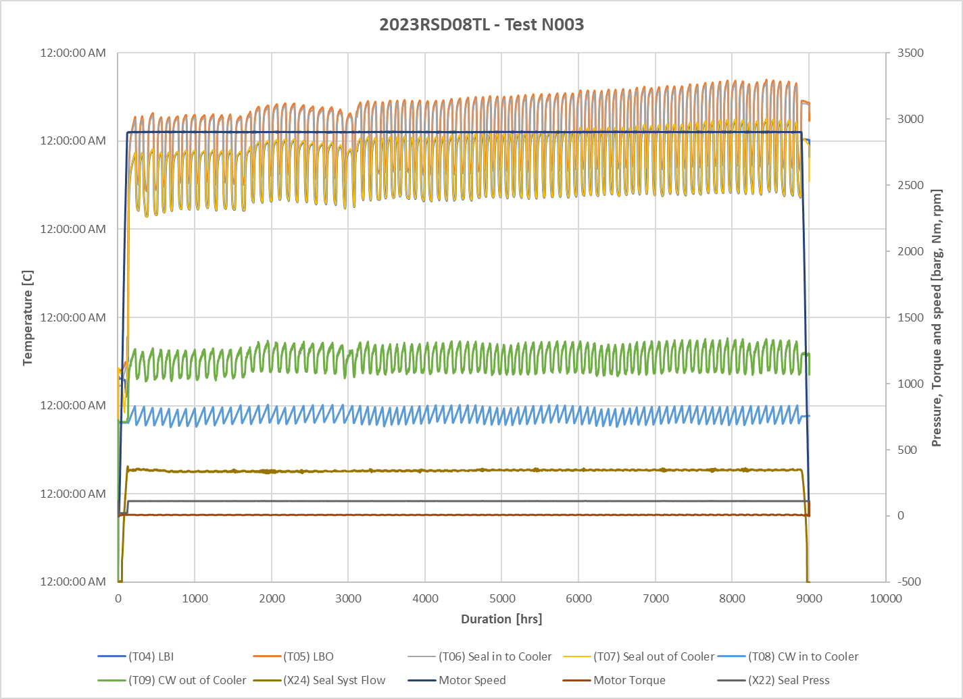

All parameters were stable during the test (temperature, pressure and leakage)
Leakage was steady during the whole testing period.
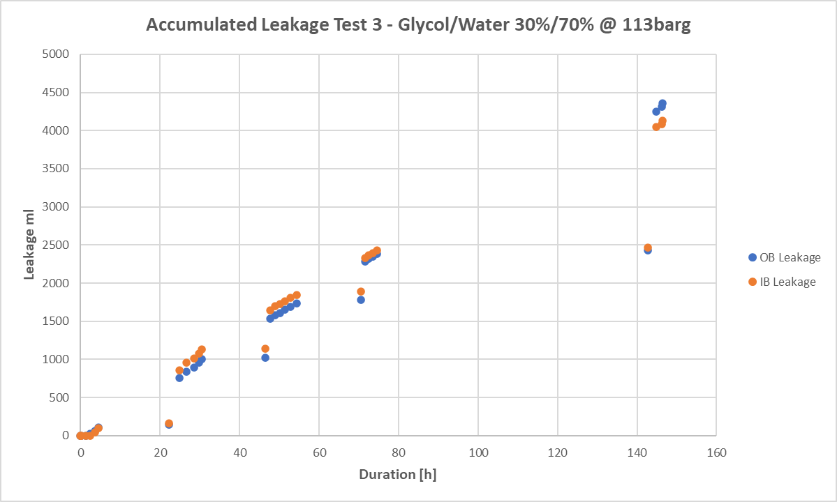

Manually Logged Data
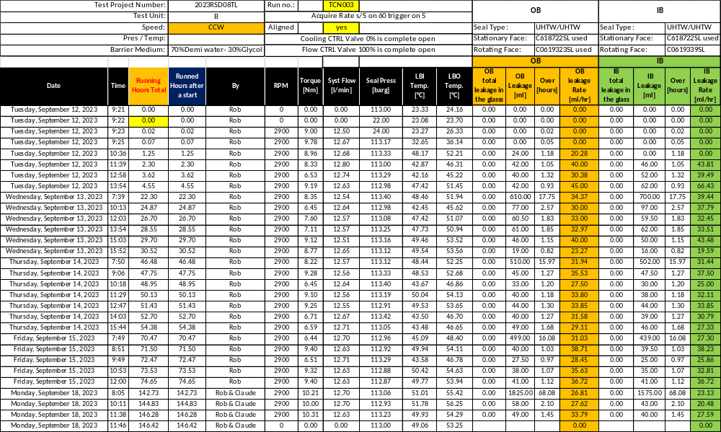

Measurements Results
Leakage rate
 | Inner Seal | Outer Seal
Total Run time [h] | 146.4 | 146.4
Total Seal Leakage [ml] | 4128 | 4360
Seal Leakage Rate [ml/h] | 28.2 | 29.7

Post-Test Pictures
IB Rotor | IB Stator
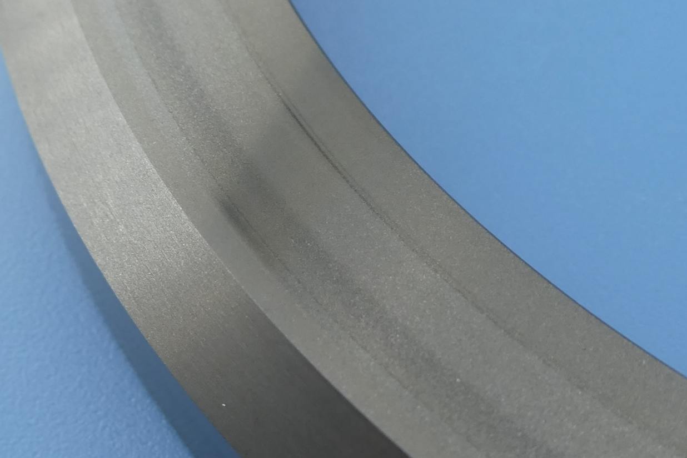 | 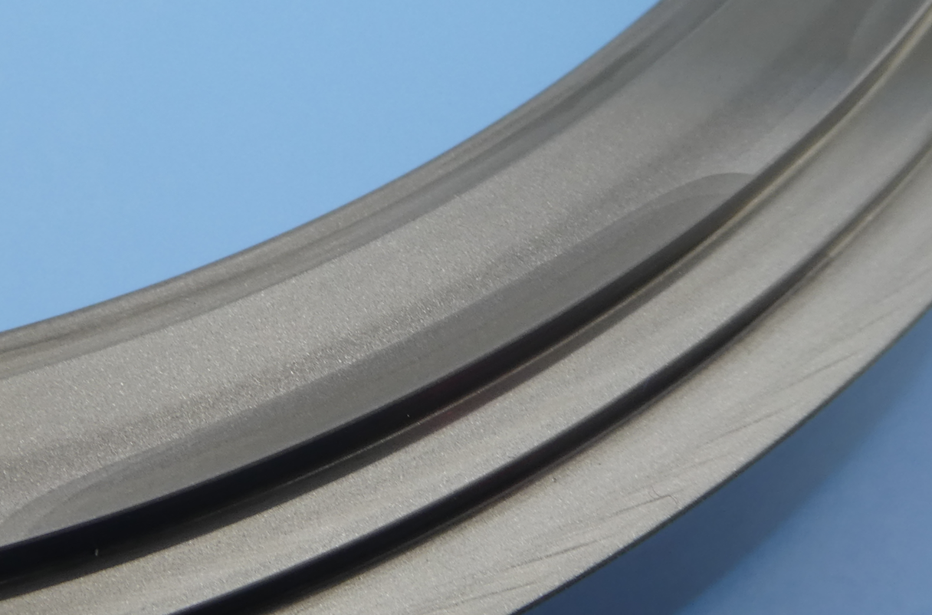
Ra | Ra

OB Rotor | OB Stator
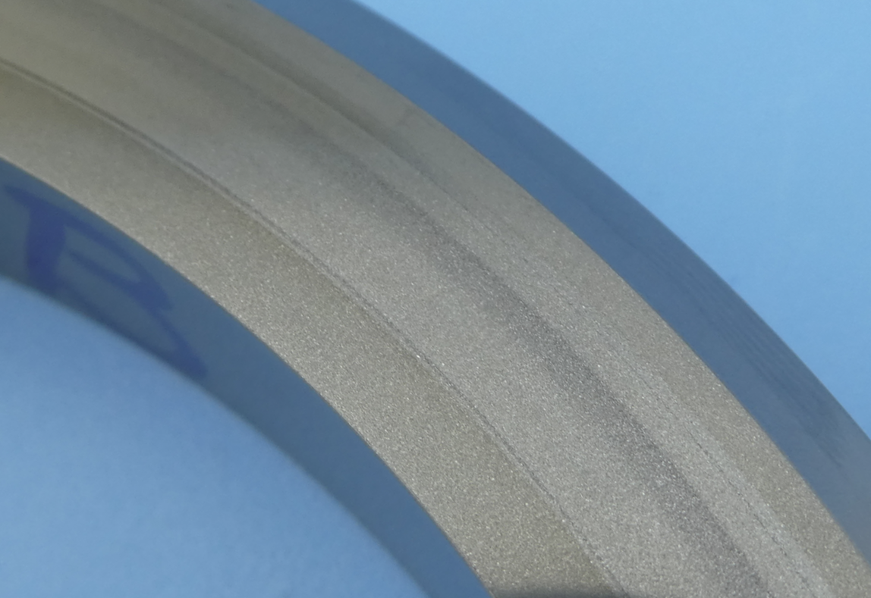 | 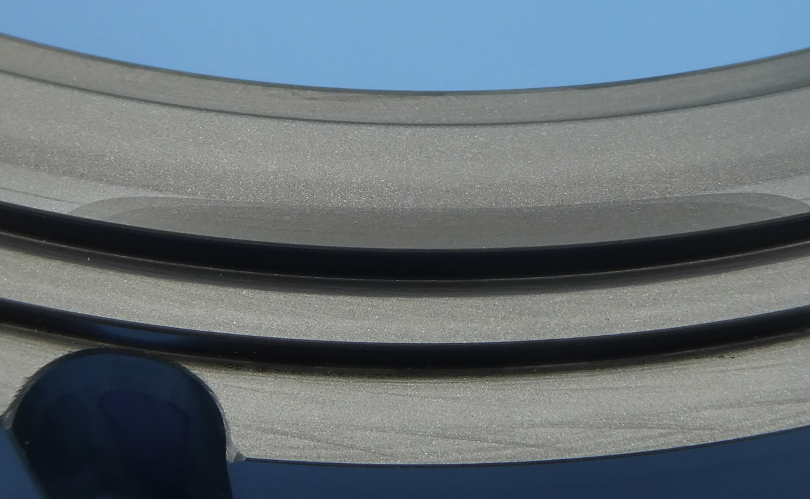
Ra | Ra

Test Conclusion
The third test results showed very stable seal performance using Ethylene Glycol and water mixture, the leakage was low and within acceptable limits.
Seal faces didn’t show any damage or deterioration for the duration of the test exceeding 144h. This conclude that seal faces are suitable for Ethylene glycol and 113barg.

